1

SRI VENKATESWARA COLLEGE OF ENGINEERING

PENNALUR, SRIPERUMBUDUR

IT16301-COA
UNIT – 5


MULTIPROCESSORS

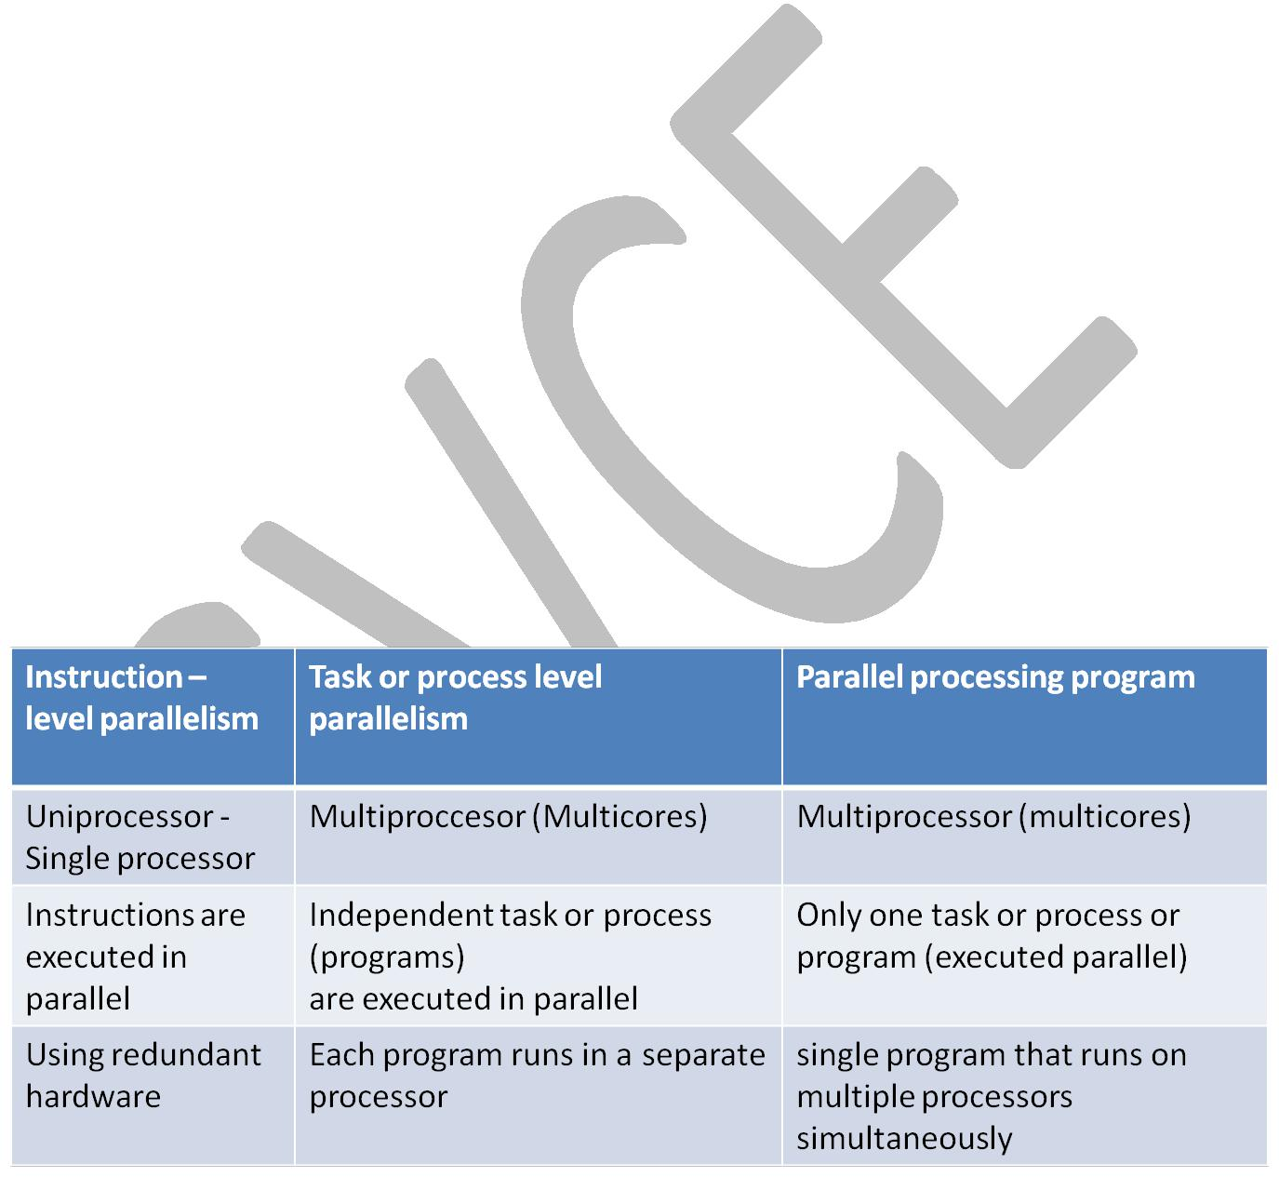
Connecting multiple computers (processors) to get higher performance is the goal of multiprocessors. Processors – also called as cores. Multi-core microprocessors are chips with multiple processors (cores).

Multiprocessor - A computer system with at least two processors. This computer is in contrast to a uni-processor, which has one, and is increasingly hard to find today.

Task-level parallelism or Process-level parallelism - Utilizing multiple processors by running independent programs simultaneously.

Parallel processing program - A single program that runs on multiple processors simultaneously.

Instruction level parallelism - Instructions are executed in parallel.
Task-level (process-level) parallelism - High throughput for independent jobs (programs).
Parallel processing program - Single program run on multiple processors.

Hardware and Software:
Hardware

– Serial: e.g., Pentium 4

– Parallel: e.g., Intel core i-7
Software

– Sequential: e.g., matrix multiplication

– Concurrent: e.g., operating system
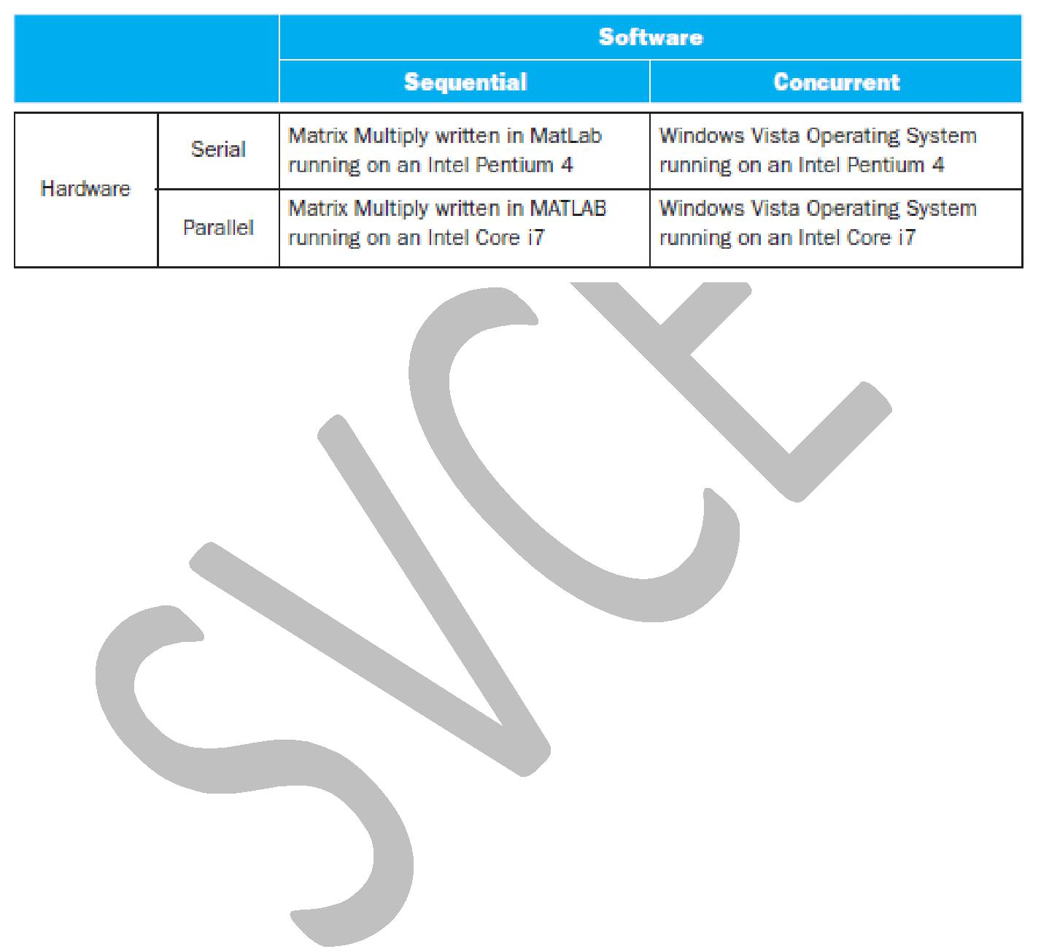

Sequential/concurrent software can run on serial/parallel hardware. But the challenge is making effective use of parallel hardware.

CHALLENGES IN PARALLEL PROCESSING PROGRAMS

Parallel processing programs are much hard to develop than sequential processing programs.

A parallel processing program on a multiprocessor gives better performance and efficiency from multiprocessor.

For sequential program on a uniprocessor, programming is easier. Since, uni-processor design techniques such as superscalar and out-of-order execution take advantage of instruction-level parallelism normally without the involvement of the programmer.

Parallel Programming challenges for the programmer:

- Programmer overhead in writing a parallel code
- Partitioning – partition the code into independent segments.
- Each partition of same size – each partition should be of same size.

  - Communications overhead – communication between the partitions cause extra overhead.

- Need to get significant performance improvement – parallel programming should result in performance improvement.

Amdahl’s law:

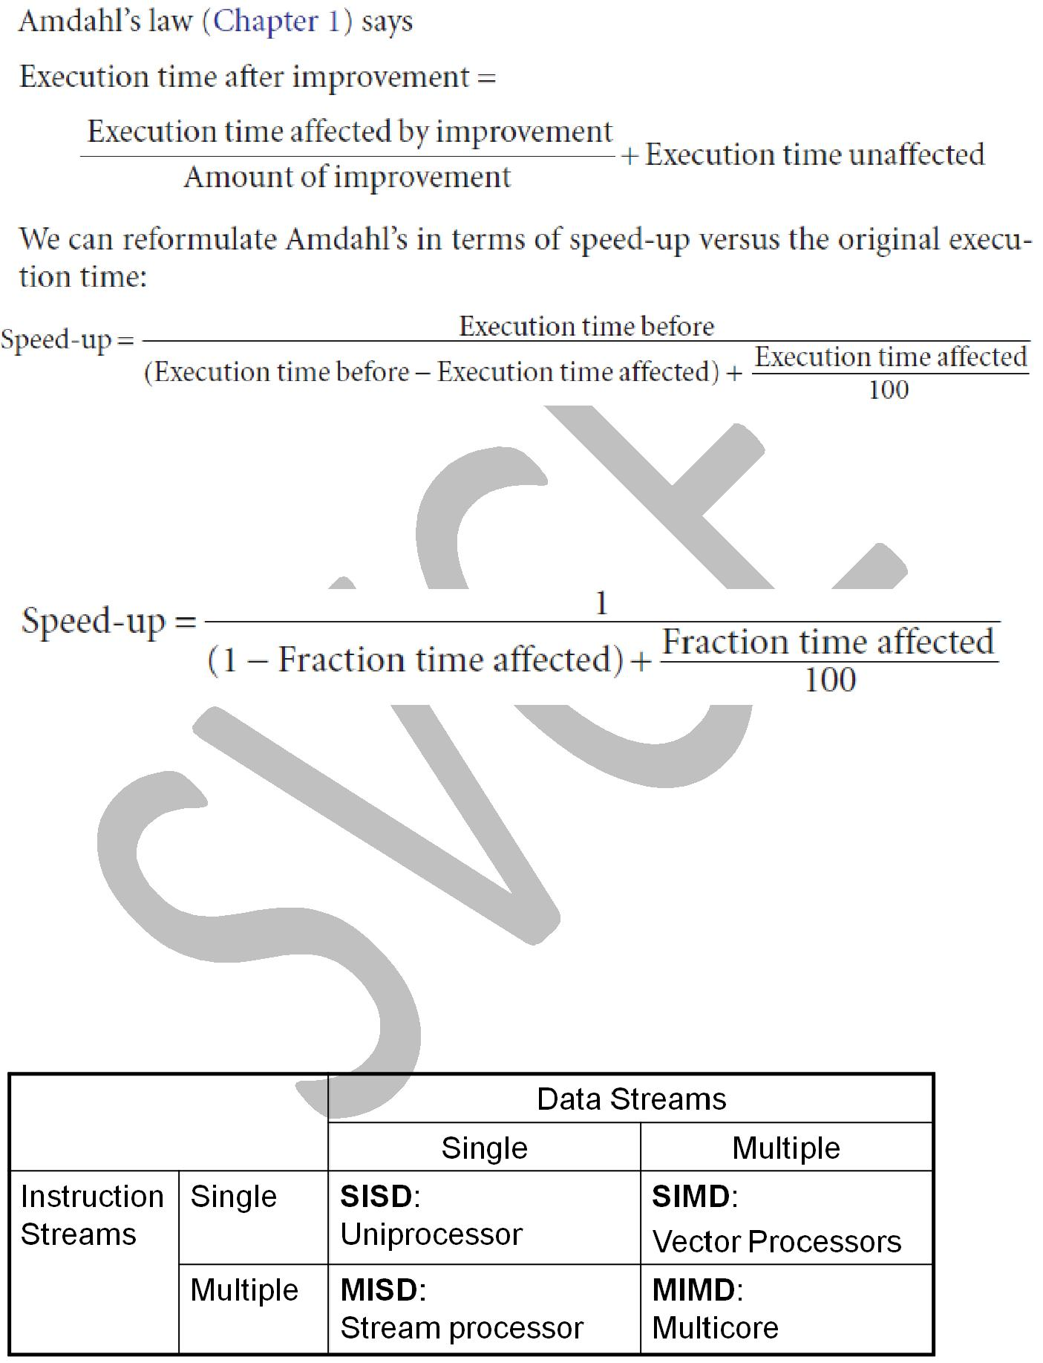

This formula is usually rewritten assuming that the execution time before is 1 for some unit of time, and the execution time affected by improvement is considered the fraction of the original execution time:

Speed-up Challenge: (Refer written notes)

FLYNN'S CLASSIFICATION:

- SISD – Single Instruction Single Data stream
- SIMD – Single Instruction Multiple Data stream
- MISD – Multiple Instruction Single Data stream
- MIMD – Multiple Instruction Multiple Data stream

SISD – Single Instruction and Single Data stream
- A conventional uniprocessor
- Ex: Intel Pentium 4

MIMD – Multiple Instruction and Multiple Data stream
- A conventional multiprocessor

- Ex: Intel core i7

- SPMD - Single Program Multiple Data is the conventional MIMD programming model, where a single program runs across all processors.

- A parallel program on a MIMD computer.

While it is possible to write separate programs that run on different processors

on a MIMD computer and yet work together for a grander, coordinated goal, programmers normally write a single program that runs on all processors of an MIMD computer, relying on conditional statements when different processors should execute different sections of code. This style is called Single Program Multiple Data (SPMD).

Ex: Conditional code for different processors
If(a==1)
{
//execute in Processor 1
}
Else if (a==2)
{
//execute in Processor 2
}

MISD – Multiple Instruction Single Data Stream
- Apply multiple operations on single data stream
- Ex: Stream processor

On single data stream, multiple operations are applied at the same time. In the figure below, on single data pair (A and B) multiple operations(add, subtract, multiply, divide) are applied at the same time.

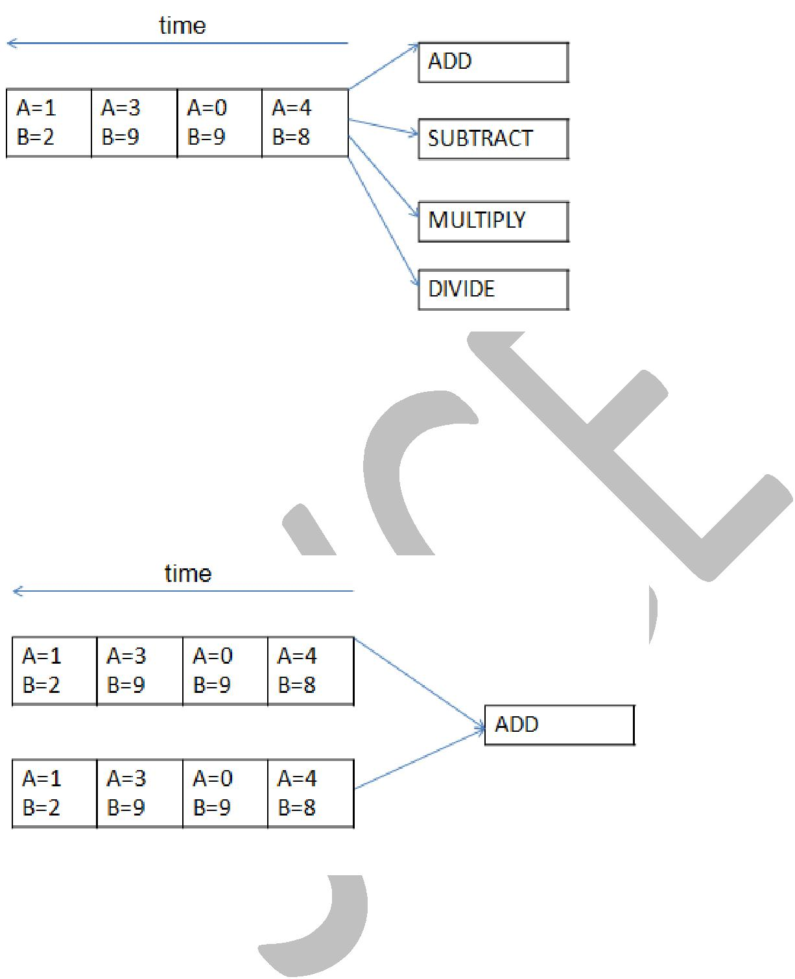

SIMD – Single Instruction and Multiple Data stream
- The same instruction is applied to many data streams, as in a vector processor.
- Apply single operations on multiple data stream

- Ex: Vector processor

On multiple data streams, single operation is applied. In the figure below, on multiple data pair (A and B) multiple operations (add, subtract, multiply, divide) are applied at the same time.

The inverse of MISD is much more popular. SIMD computers operate on vectors of data.
For example, a single SIMD instruction might add 64 numbers by sending 64 data streams to 64
ALUs to form 64 sums within a single clock cycle. It is similar to sub-word parallelism.
Another name for SIMD is data-level parallelism.

The original motivation behind SIMD was to amortize the cost of the control unit over dozens of execution units. Another advantage is the reduced instruction bandwidth and space. SIMD needs only one copy of the code that is being simultaneously executed.

SIMD works best when dealing with arrays in for loops. Hence, for parallelism to work in SIMD, there must be a great deal of identically structured data, which is called data-level

parallelism. SIMD is at its weakest in case or switch statements, where each execution unit must perform a different operation on its data, depending on what data it has.

Execution units with the wrong data must be disabled so that units with proper data may continue. If there are n cases, in these situations SIMD processors essentially run at 1/nth of peak performance.

Data-level parallelism - Parallelism achieved by performing the same operation on independent data.

SIMD - VECTOR:

An older and, as we shall see, more elegant interpretation of SIMD is called a vector architecture. Rather than having 64 ALUs perform 64 additions simultaneously, like the old array processors, the vector architectures pipelined the ALU to get good performance at lower cost. The basic philosophy of vector architecture is to collect data elements from memory, put them in order into a large set of registers, operate on them sequentially in registers using pipelined execution units, and then write the results back to memory. A key feature of vector architectures is then a set of vector registers. Thus, vector architecture might have 32 vector registers, each with 64 64-bit elements

Vector versus Scalar

Vector instructions have several important properties compared to conventional instruction set architectures, which are called scalar architectures in this context:

- A single vector instruction specifies a great deal of work. It is equivalent to executing an entire loop. The instruction fetch and decode bandwidth needed is dramatically reduced.

- By using a vector instruction, the compiler or programmer indicates that the computation of each result in the vector is independent of the computation of other results in the same vector, so hardware does not have to check for data hazards within a vector instruction.

- Vector architectures and compilers have a reputation of making it much easier than when using MIMD multiprocessors to write efficient applications when they contain data-level parallelism.

- Hardware need only check for data hazards between two vector instructions once per vector operand, not once for every element within the vectors. Reduced checking can save energy as well as time.

- Vector instructions that access memory have a known access pattern. If the vector elements are all adjacent, then fetching the vector from a set of heavily interleaved memory banks works very well. Thus, the cost of the latency to main memory is seen only once for the entire vector, rather than once for each word of the vector.

- Because an entire loop is replaced by a vector instruction whose behavior is predetermined, control hazards that would normally arise from the loop branch are non-existent.

- The savings in instruction bandwidth and hazard checking plus the efficient use of memory bandwidth give vector architectures advantages in power and energy versus scalar architectures.

For these reasons, vector operations can be made faster than a sequence of scalar operations on the same number of data items, and designers are motivated to include vector units if the application domain can often use them.

The below table highlights the above points in a tabular form:
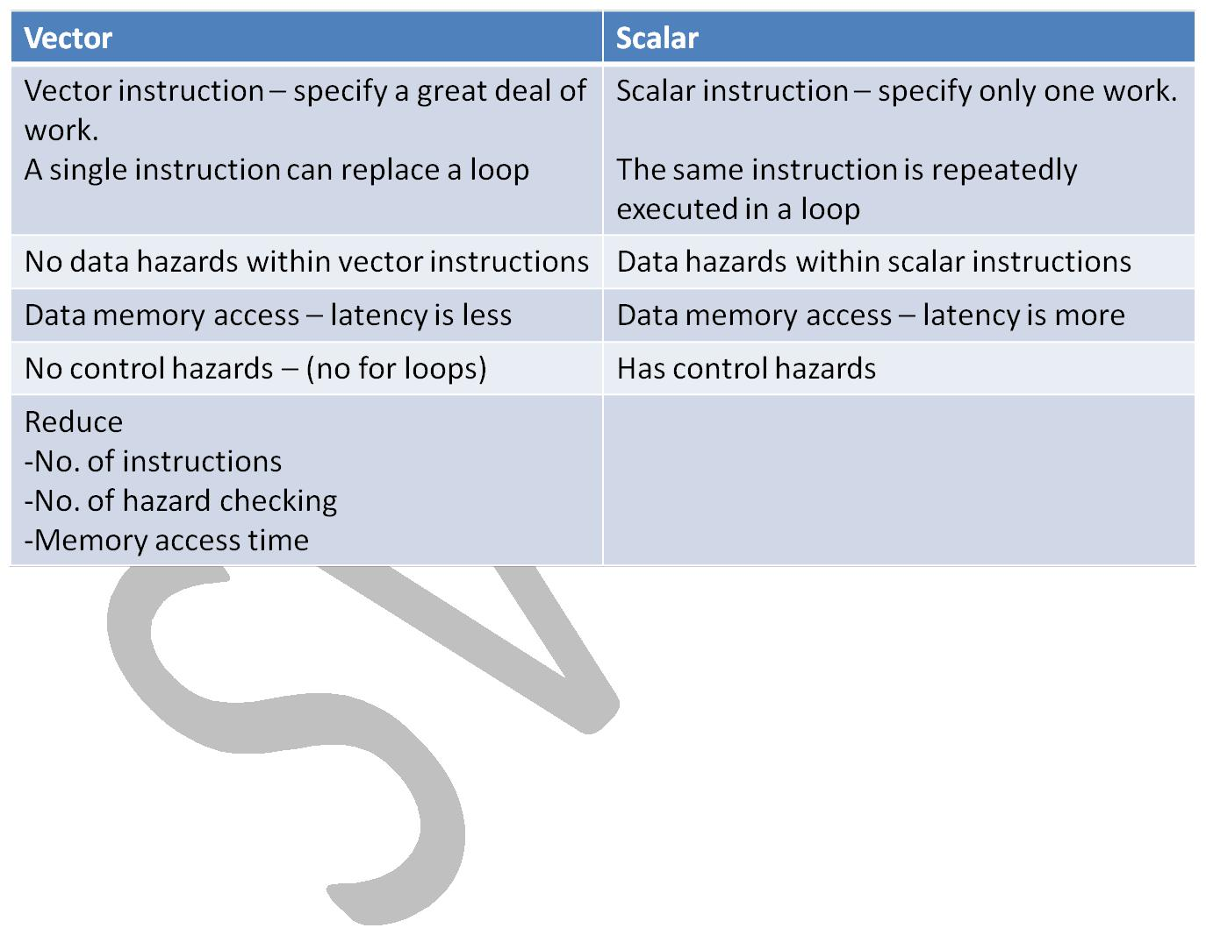

Vector Instructions:

Example: Vector instructions

- lv, sv: load/store vector

- addv.d: add vectors of double

- addvs.d: add scalar to each element of vector of double

Vector versus Multimedia Extensions:

Vector architectures easily capture the flexibility in data widths, so it is easy to make a vector operation work on 32 64-bit data elements or 64 32-bit data elements or 128 16-bit data elements or 256 8-bit data elements.

The parallel semantics of a vector instruction allows an implementation to execute these operations using a deeply pipelined functional unit, an array of parallel functional units, or a combination of parallel and pipelined functional units.

The below figure illustrates how to improve vector performance by using parallel pipelines to execute a vector add instruction.

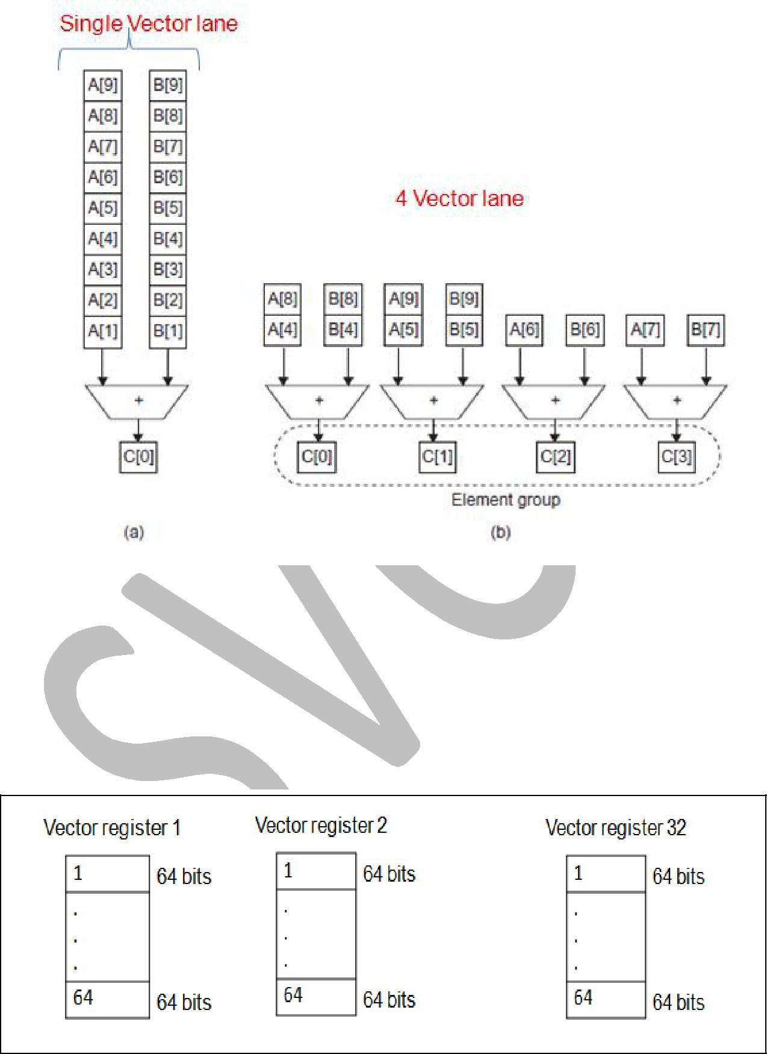

The above figure uses multiple functional units to improve the performance of a single vector add instruction, C = A + B. The vector processor (a) on the left has a single add pipeline and can complete one addition per cycle. The vector processor (b) on the right has four add pipelines or lanes and can complete four additions per cycle. The elements within a single vector add instruction are interleaved across the four lanes.

Vector Register File:
Vector register file – has 32 vector registers. Each vector register – has 64 (64 bit elements)

…..……..

Vector lane - One or more vector functional units and a portion of the vector register file. Inspired by lanes on highways that increase traffic speed, multiple lanes execute vector operations simultaneously.

To increase the peak throughput of a vector unit by adding more lanes. The below figure shows the structure of a four-lane vector unit. Thus, going to four lanes from one lane reduces the number of clocks per vector instruction by roughly a factor of four.

In the below figure, the vector-register storage is divided across the lanes, with each lane holding every fourth element of each vector register. The figure shows three vector functional units: an FP add, an FP multiply, and a load-store unit. Each of the vector arithmetic units contains four execution pipelines, one per lane, which acts in concert to complete a single vector instruction.
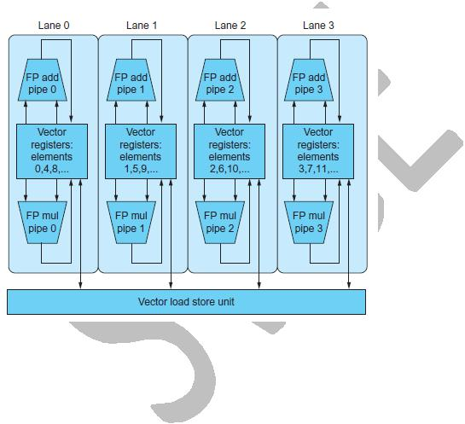

HARDWARE MULTITHREADING:

Program is a sequence of instructions. Program in execution is called Process. Thread is a light weight process. Where each process can be divided into multiple threads.

Thread - A thread includes the program counter, the register state, and the stack. It is a lightweight process; whereas threads commonly share a single address space, processes don’t.

Process - A process includes one or more threads, the address space, and the operating system state. Hence, a process switch usually invokes the operating system, but not a thread switch.

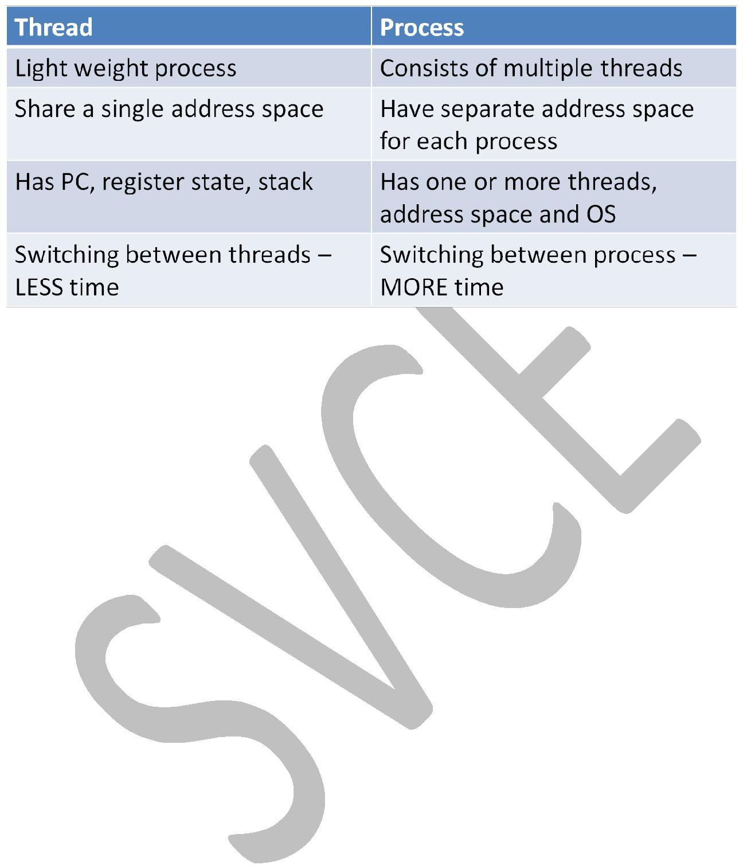

Hardware multithreading - Increasing utilization of a processor by switching to another thread when one thread is stalled.

3 types of multithreading:
– Fine-grain multithreading

– Coarse-grain multithreading
– Simultaneous multithreading

Fine - grained multithreading - A version of hardware multithreading that implies switching between threads after every instruction.

Fine-grained multithreading switches between threads on each instruction, resulting in interleaved execution of multiple threads. This interleaving is often done in a round-robin fashion, skipping any threads that are stalled at that clock cycle. The processor switches threads on every clock cycle.

One advantage of fine-grained multithreading is that it can hide the throughput losses that arise from both short and long stalls, since instructions from other threads can be executed when one thread stalls.

The primary disadvantage of fine-grained multithreading is that it slows down the execution of the individual threads, since a thread that is ready to execute without stalls will be delayed by instructions from other threads.

Coarse - grained multithreading - A version of hardware multithreading that implies switching between threads only after significant events, such as a last-level cache miss.

Coarse-grained multithreading switches threads only on costly stalls, such as last-level cache misses. This change relieves the need to have thread switching be extremely fast and is much less likely to slow down the execution of an individual thread, since instructions from other threads will only be issued when a thread encounters a costly stall.

Coarse-grained multithreading has a major drawback: it is limited in its ability to overcome throughput losses, especially from shorter stalls. This limitation arises from the pipeline start-up costs of coarse-grained multithreading. Because a processor with coarse-grained multithreading issues instructions from a single thread, when a stall occurs, the pipeline must be emptied or frozen. The new thread that begins executing after the stall must fill the pipeline before instructions will be able to complete. Due to this start-up overhead, coarse-grained multithreading is much more useful for reducing the penalty of high-cost stalls, where pipeline refill is negligible compared to the stall time.

Simultaneous multithreading (SMT) - A version of multithreading that lowers the cost of multithreading by utilizing the resources needed for multiple issue, dynamically scheduled micro-architecture.
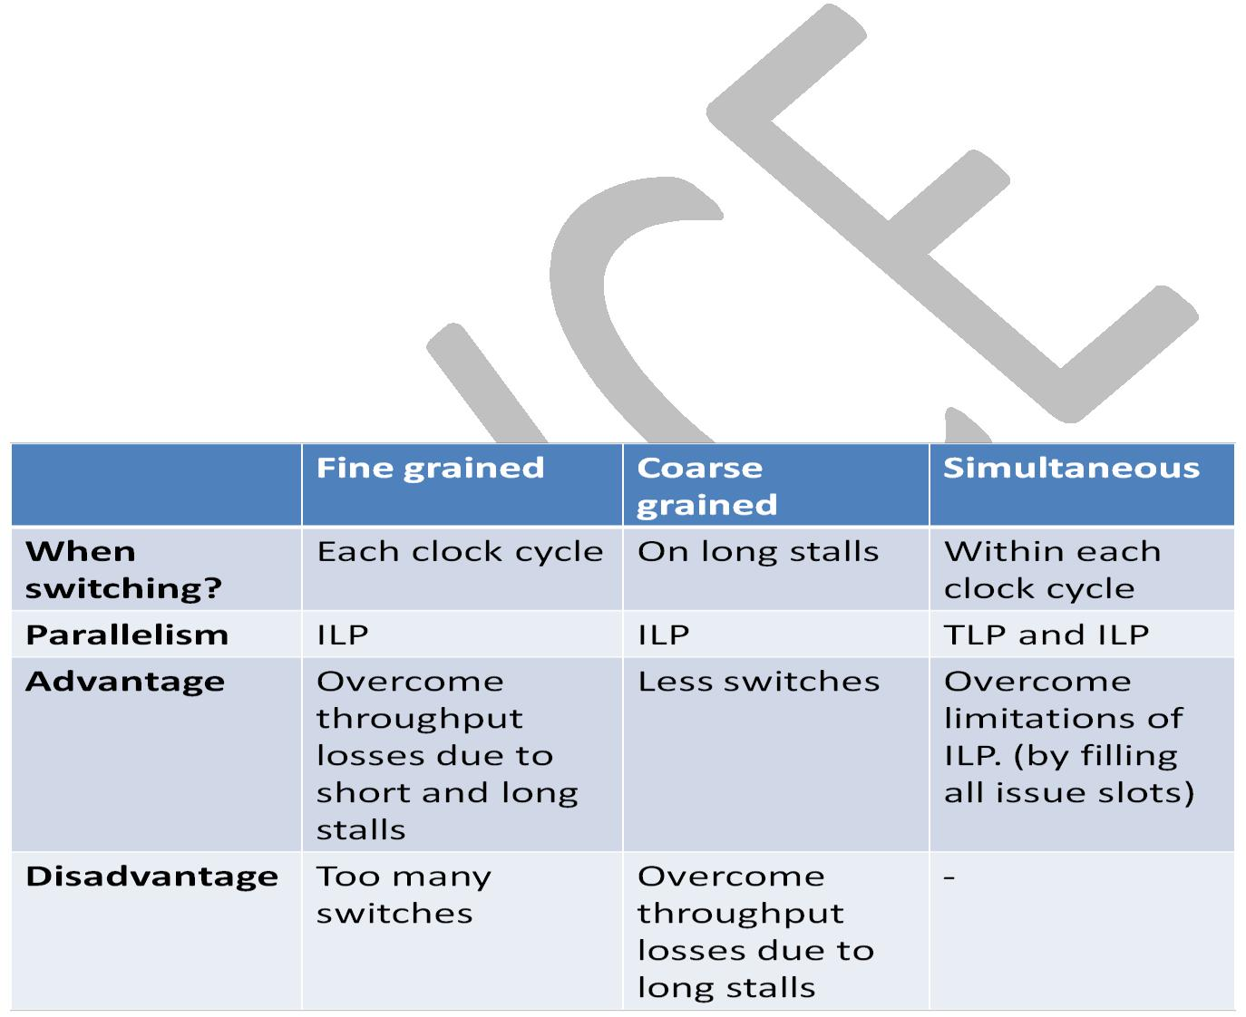

SMT is a variation on hardware multithreading that uses the resources of a multiple-issue, dynamically scheduled pipelined processor to exploit thread-level parallelism at the same time it exploits instruction level parallelism

Multiple instructions from independent threads can be issued without regard to the dependences among them; the resolution of the dependences can be handled by the dynamic scheduling capability.

Above given points are consolidated in the below table:

Example for 4-way multi-threading:

Dynamic multiple issue with 4 instructions per issue packet can start to execute 4 instructions at the same clock cycle.

How four threads use the issue slots of a superscalar processor in different approaches. The four threads at the top show how each would execute running alone on a standard superscalar processor without multithreading support. The three examples at the bottom show how they would execute running together in three multithreading options. The horizontal dimension represents the instruction issue capability in each clock cycle. The vertical dimension represents a sequence of clock cycles. An empty (white) box indicates that the corresponding issue slot is unused in that clock cycle. The shades of gray and color correspond to four different threads in the multithreading processors.
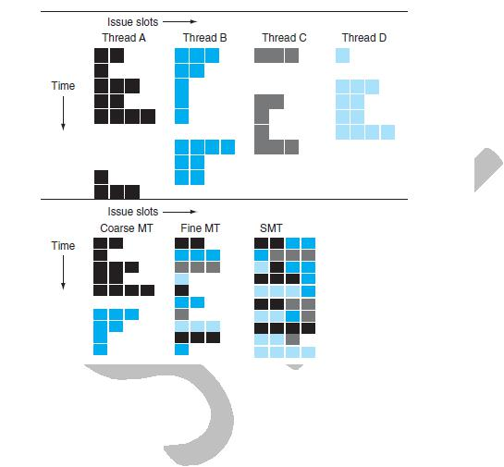

In the above figure, the top portion shows how four threads would execute independently on a superscalar with no multithreading support. The bottom portion shows how the four threads could be combined to execute on the processor more efficiently using three multithreading options:

- A superscalar with coarse-grained multithreading

- A superscalar with fine-grained multithreading
- A superscalar with simultaneous multithreading

- In the superscalar without hardware multithreading support, the use of issue slots is limited by a lack of instruction-level parallelism. In addition, a major stall, such as an instruction cache miss, can leave the entire processor idle.

- In the coarse-grained multithreaded superscalar, the long stalls are partially hidden by switching to another thread that uses the resources of the processor. Although this reduces the number of completely idle clock cycles, the pipeline start-up overhead still leads to idle cycles, and limitations to ILP means all issue slots will not be used.

- In the fine-grained case, the interleaving of threads mostly eliminates idle clock cycles. Because only a single thread issues instructions in a given clock cycle, however, limitations in instruction-level parallelism still lead to idle slots within some clock cycles.

- In the SMT case, thread-level parallelism and instruction-level parallelism are both exploited, with multiple threads using the issue slots in a single clock cycle.
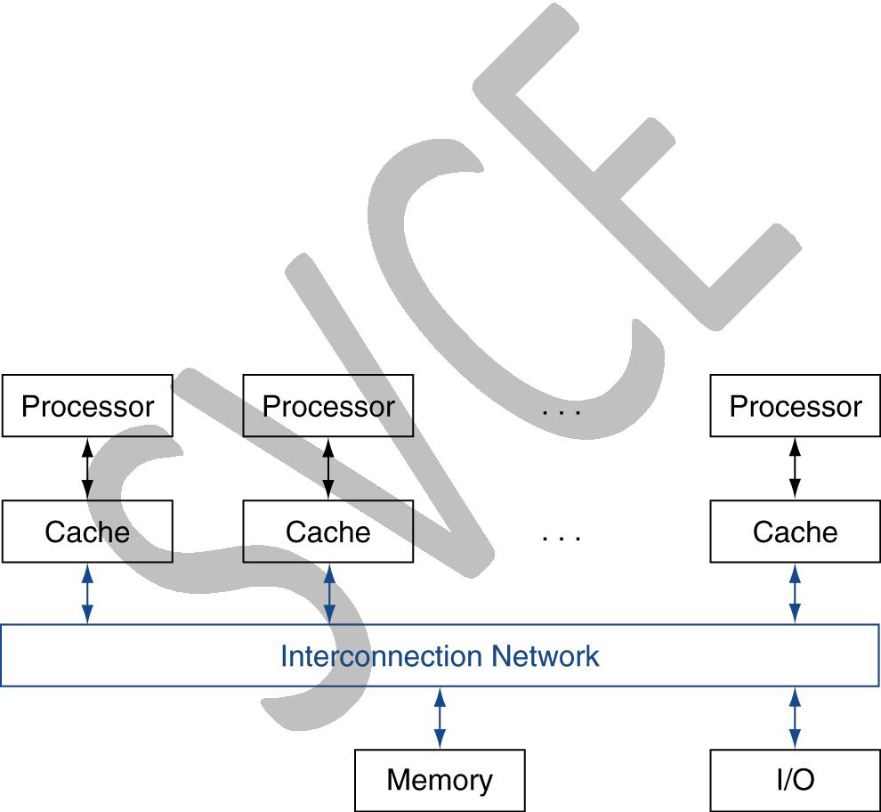

MULTICORE AND OTHER SHARED MEMORY MULTIPROCESSORS

Multicore – multiple processors.

A shared memory multiprocessor (SMP) is one that offers the programmer a single physical address space across all processors.

Processors communicate through shared variables in memory, with all processors capable of accessing any memory location via loads and stores.

The diagram given below shows the classic organization of SMP.

Synchronize shared variables using locks:

Synchronization - The process of coordinating the behavior of two or more processes, which may be running on different processors.

Lock - A synchronization device that allows access to data to only one processor at a time.

As processors operating in parallel will normally share data, they also need to coordinate when operating on shared data; otherwise, one processor could start working on data before another is finished with it. This coordination is called synchronization. When sharing is supported with a single address space, there must be a separate mechanism for synchronization. One approach uses a lock for a shared variable. Only one processor at a time can acquire the lock, and other processors interested in shared data must wait until the original processor unlocks the variable.
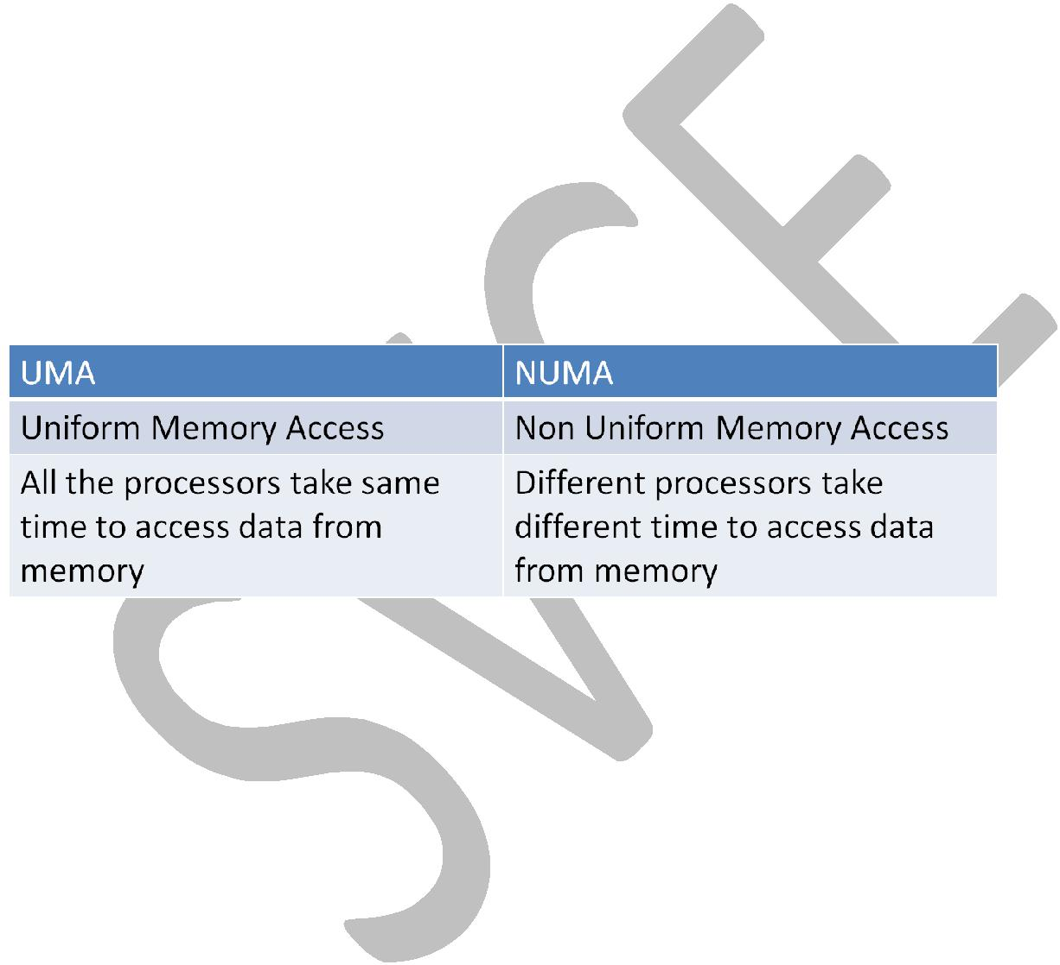

Memory Access:

Uniform memory access (UMA) - A multiprocessor in which latency to any word in main memory is about the same no matter which processor requests the access.

Non-uniform memory access (NUMA) - A type of single address space multiprocessor in which some memory accesses are much faster than others depending on which processor asks for which word.

Interconnection Networks:

Networks are normally drawn as graphs, with each edge of the graph representing a link of the communication network. In the below figures, the processor memory node is shown as a black square and the switch is shown as a colored circle. We assume here that all links are bidirectional; that is, information can flow in either direction. All networks consist of switches whose links go to processor memory nodes and to other switches.

Performance metrics for different networks:

Performance metrics for network:

- Network bandwidth
- Bisection bandwidth

Network bandwidth - Informally, the peak transfer rate of a network; can refer to the speed of a single link or the collective transfer rate of all links in the network.

Bisection bandwidth - The bandwidth between two equal parts of a multiprocessor. This measure is for a worst case split of the multiprocessor.

Network topology:
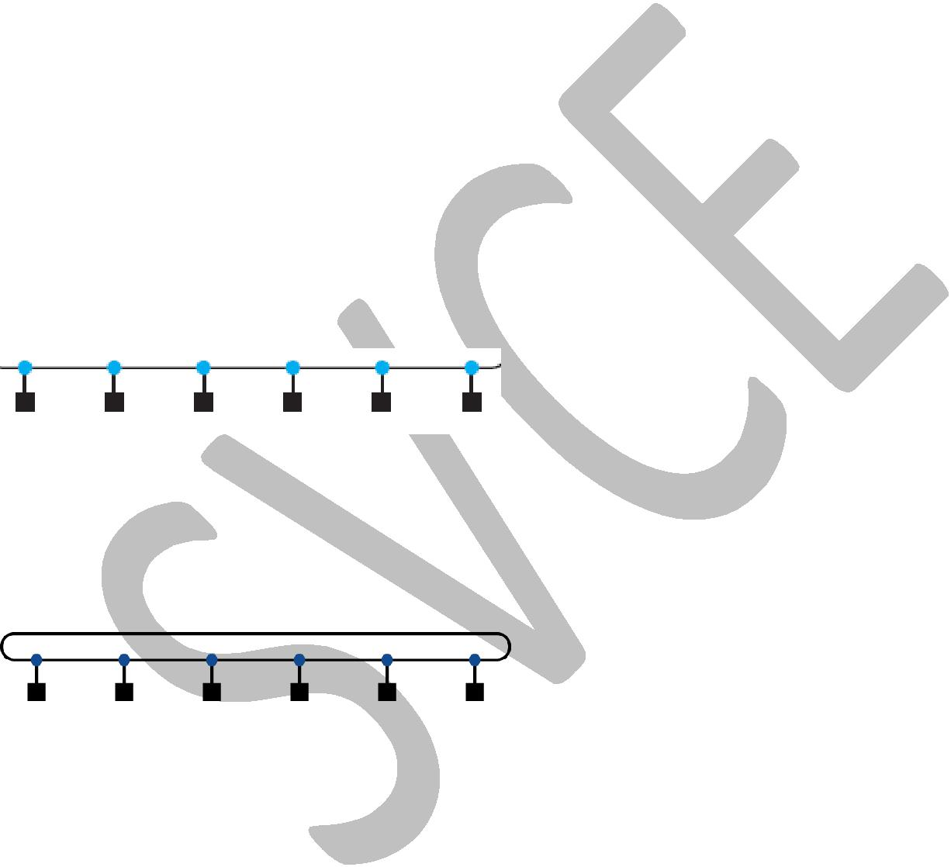
- Bus
- Ring
- Mesh
- Cube

- Fully connected

Bus:

The bus topology connects a sequence of nodes together in a single shared line. Where only one device can broadcast signals to all connected devices at a time.

Ring:

The ring topology connects a sequence of nodes together. Since some nodes are not directly connected, some messages will have to hop along intermediate nodes until they arrive at the final destination. Simulataneous transfers are possible in ring.

Mesh:

Mesh and n-cube are Network topologies that have appeared in commercial parallel processors.

The below diagram shows a 2-D grid or mesh topology with 16 nodes. Where each row and column is connected through a ring topology.



n - cube:
The Boolean n-cube topology is an n-dimensional interconnect with 2^{n} nodes, requiring n links per switch (plus one for the processor) and thus n nearest-neighbor nodes.

The below diagram shows a 3-cube topology with 2³ = 8 nodes. Each switch has 4 links (3 for nearest neighbor nodes and 1 for the processor itself).

Fully connected:

Every processor has a bidirectional link to every other processor. Fully connected network - A network that connects processor memory nodes by supplying a dedicated communication link between every node.

For fully connected networks, the total network bandwidth is P × (P – 1)/2, and the bisection bandwidth is (P/2)². If P = 4, then the network bandwidth is 6 and the bisection bandwidth is 4.

Advantage: The tremendous improvement in performance of fully connected networks is offset by the tremendous increase in cost (disadvantage). This consequence inspires engineers to invent new topologies that are between the cost of rings and the performance of fully connected networks.

Multistage network:
A network that supplies a small switch at each node.

Two types:

- Cross bar network
- Omega network

Crossbar network
Every processor is connected to every other processor directly.

A network that allows any node to communicate with any other node in one pass through the network.

Advantage: All communication links are one hop in length.

Disadvantage: Crossbar network requires too many switches. The number of switches in a cross bar network is N². N is the number of processors. In the above diagram, there are 8 processors and so 64 switches. The crossbar, however, can support any combination of messages between processors

The switches in the below figure are simpler than in earlier drawings because the links are unidirectional; data comes in at the left and exits out the right link.

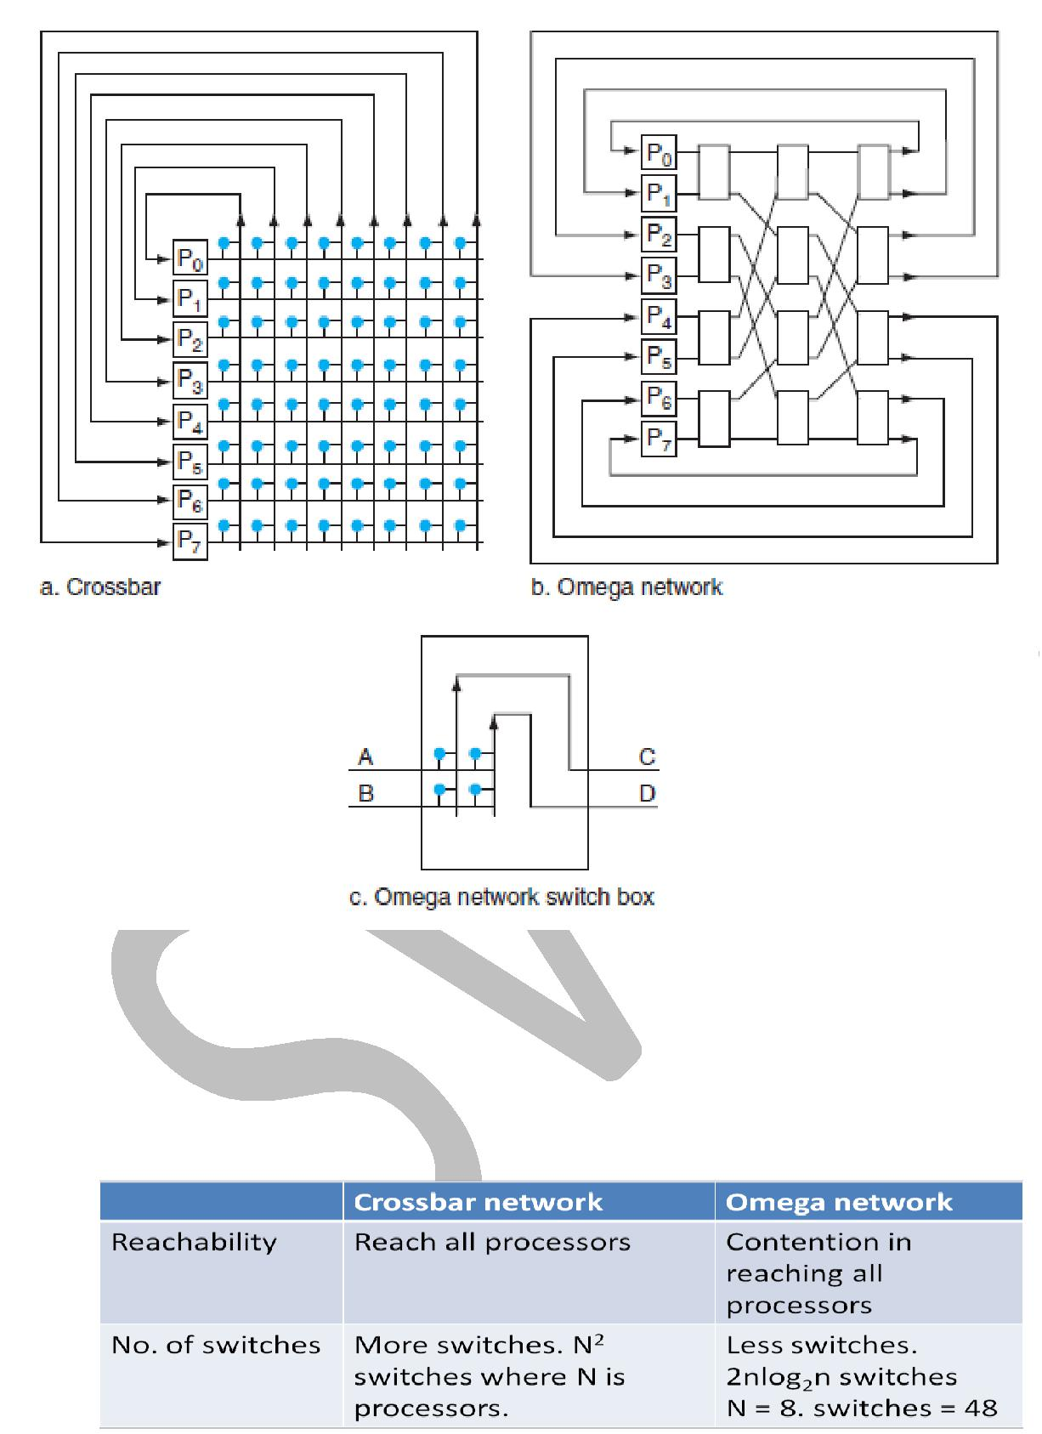

Omega Network:

The switch box in the above diagram under ’c’ can pass A to C and B to D or B to C and A to D. The Omega network uses 2n log₂n of the large switch boxes, each of which is logically composed of four of the smaller switches. where n is the number of processors. In this case, the omega network uses 12 switch boxes, or 48 switches when n=8 processors. The omega network however, cannot support any combination of messages between processors.

PERFORMANCE MODEL:

Arithmetic intensity - The ratio of floating point operations in a program to the number of data bytes accessed by a program from main memory.

Arithmetic intensity = no. of floating point operations in program
-------------------------------------------------------------------
no. of data bytes accessed from memory by program

The Roofline Model:

This simple model ties floating-point performance, arithmetic intensity, and memory performance together in a two-dimensional graph.

The vertical Y-axis is achievable floating-point performance from 0.5 to 64.0 GFLOPs/second. The horizontal X-axis is arithmetic intensity, varying from 1/8 FLOPs/DRAM byte accessed to 16 FLOPs/DRAM byte accessed.
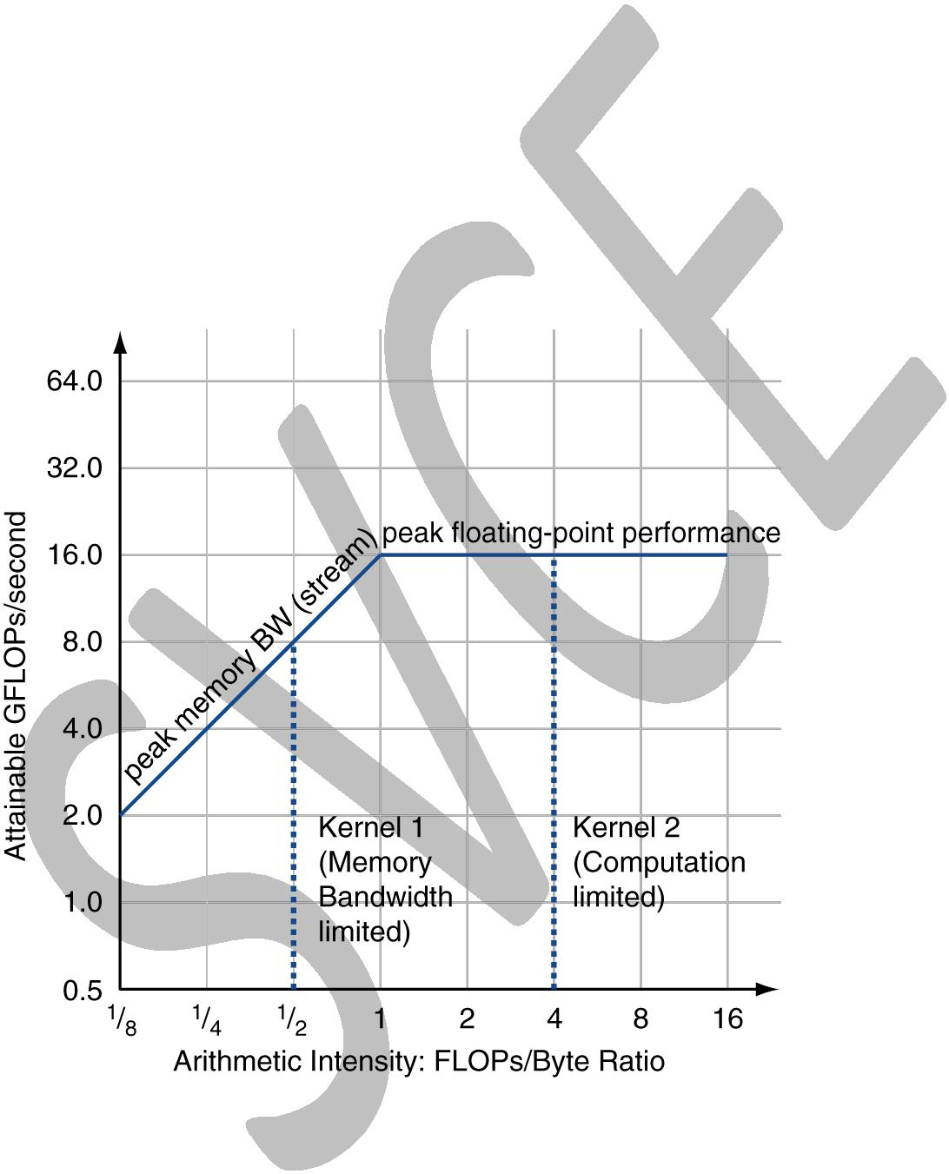
For a given kernel, we can find a point on the X-axis based on its arithmetic intensity. If we draw a vertical line through that point, the performance of the kernel on that computer must lie somewhere along that line. We can plot a horizontal line showing peak floating-point performance of the computer. Obviously, the actual floating-point performance can be no higher than the horizontal line, since that is a hardware limit.

In the example given in the above graph, has a peak floating-point performance of 16 GFLOPS/sec and a peak memory bandwidth of 16 GB/sec.

The dotted vertical line in color on the left represents Kernel 1, which has an arithmetic intensity of 0.5 FLOPs/ byte. It is limited by memory bandwidth to no more than 8 GFLOPS/sec.

The dotted vertical line to the right represents Kernel 2, which has an arithmetic intensity of 4 FLOPs/byte. It is limited only computationally to 16 GFLOPS/s.

How could we plot the peak memory performance, which is measured in bytes/second?

Since the X-axis is FLOPs/byte and the Y-axis FLOPs/second, bytes/second is just a diagonal line at a 45-degree angle in this figure. Hence, we can plot a third line that gives the maximum floating-point performance that the memory system of that computer can support for a given arithmetic intensity.

Attainable GFLOPs/sec = Min (Peak Memory BW × Arithmetic Intensity, Peak Floating-Point Performance)

The horizontal and diagonal lines give this simple model its name and indicate its value. The roofline sets an upper bound on performance of a kernel depending on its arithmetic intensity.
If we think of arithmetic intensity as a pole that hits the roof, either it hits the slanted part of the roof, which means performance is ultimately limited by memory bandwidth, or it hits the flat part of the roof, which means performance is computationally limited.

The ridge point, where the diagonal and horizontal roofs meet, offers an interesting insight into the computer. If it is far to the right, then only kernels with very high arithmetic intensity can achieve the maximum performance of that computer. If it is far to the left, then almost any kernel can potentially hit the maximum performance.

To reduce computational bottlenecks, the following two optimizations can help almost any kernel:

- Floating-point operation mix. Peak floating-point performance for a computer typically requires an equal number of nearly simultaneous additions and multiplications. That balance is necessary because the floating-point unit has an equal number of floating-point adders and floating-point multipliers.

- Improve instruction-level parallelism and apply SIMD. For modern architectures, the highest performance comes when fetching, executing, and committing three to four instructions per clock cycle. The goal for this step is to improve the code from the compiler to increase ILP by unrolling loops.

To reduce memory bottlenecks, the following two optimizations can help:

- Software pre-fetching. Predicting memory accesses and pre-fetch data from memory rather than waiting until the data is required by the computation.

- Memory affinity. Second optimization tries to allocate data and the threads tasked to operate on same data to the same memory-processor pair, so that the processors rarely have to access the memory of the other chips.

GRAPHICS PROCESSING UNIT
